Advanced Computer Vision Homework 1

103318119 姚磊

**Source code editor.** (DEV-C++).

**How to execute my program?**

File->Open->xxx.cpp.

Line 271. Change the path of picture which you want to input in your computer.

Line 285. Change the path of picture which you want to output to your computer, it will rewrite the picture which you input.

Line 292. Change the path of picture which you want to output to your computer, it will get a new picture which has been done a 180-degree clockwise rotation.

Line 299. Change the path of picture which you want to output to your computer, it will generate the color negative picture.

Finally, compile and run source code.

**Method.**

Step1. Getting the width, height, and size of picture.

Step2. I reverse the order of elements in the range due to my approach to output the picture.

Step3. Writing original picture.

Step4. Reverse the order of elements in the range, that is the first element becomes the last etc. So that I will get a picture which has been done a 180-degree clockwise rotation.

Step5. 255 minus the elements which I get from picture of R, G, and B, so that I will generate the color negative picture.

**Results.**

IputImage1. (e.g. InputImage1 in attachment)

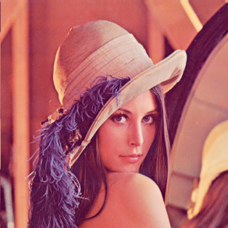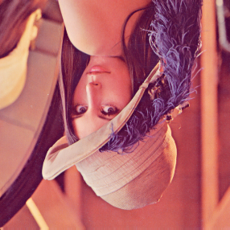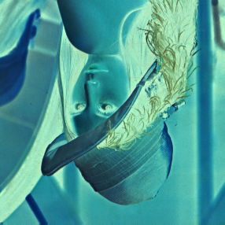

Lena64. (e.g. Lena64 in attachment)

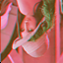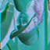

Lena1024. (e.g. Lena1024 in attachment)

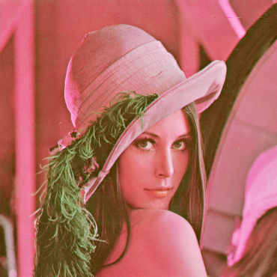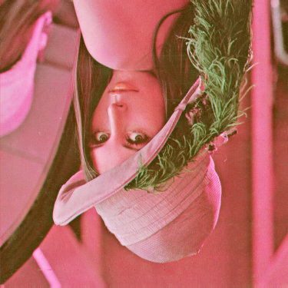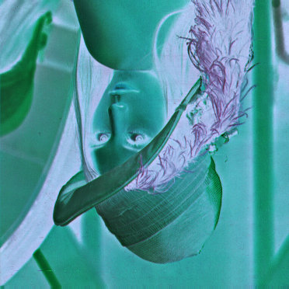

**Discussion.**

Because of little difference of the order of R, G, and B in **InputImage1**, **lena64**, and **lena1024** which download from E-learning, I must do swap R and B (e.g. Line 255~257 in HomeWork0923.cpp) when I want to output the **InputImage1**, or I will get distortion photos. (e.g. InputImage1_RB_err in attachment)

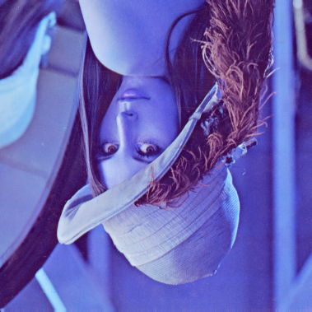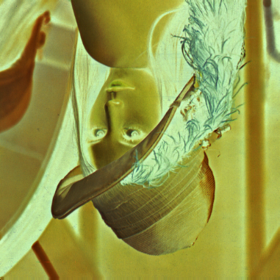

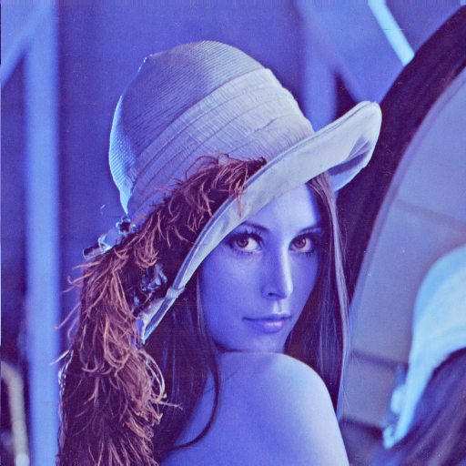

**Attachment.**

Please using HomeWork0923.cpp to process **InputImage1.bmp.**

Please using HomeWork0924.cpp to process **lena64.bmp and lena1024.bmp.**

You will get the results.